[OPINION](https://nypost.com/opinion/)

[EDITORIAL](https://nypost.com/tag/editorial/)

**Team Trump’s crackdown on campus hate is a defense of decency and a push against perverted privilege**

By

New YORK Post Editorial Board

Published March 9, 2025, 8:03 p.m. ET

132 Comments

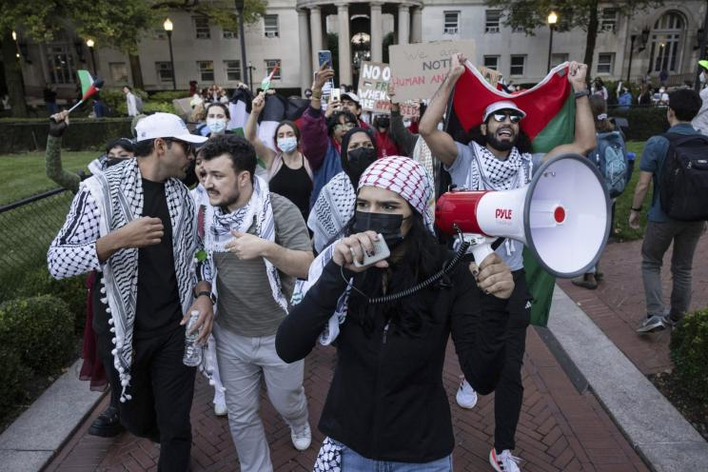Palestinian supporters including Mahmoud Khalil, second left, demonstrate during a protest at Columbia University, Thursday, Oct. 12, 2023, in New York.AP

With the reported [arrest and likely deportation](https://nypost.com/2025/03/09/us-news/ice-arrests-palestinian-leader-of-columbias-anti-israel-protests-lawyer/) of Mahmoud Khalil, a noncitizen ringleader of antisemitic protests at Columbia and Barnard, ICE has put fresh teeth on President Donald Trump’s crackdown on campus hate. Hooray!

This follows [Friday’s nixing of some $400 million](https://nypost.com/2025/03/08/us-news/funding-cuts-to-create-anxiety-concern-at-columbia-university-president/) in federal grants to and contracts with Columbia for its failure to comply with anti-discrimination laws, even as Trump’s Education Department is [eyeing four other universities](https://nypost.com/2025/02/03/us-news/trump-run-education-department-investigating-five-universities-over-alleged-antisemitic-harassment-including-columbia/) (to start) for similar treatment.

Khalil, despite finishing his graduate studies at the school in December, stuck around — plainly with an eye to continuing the disruptions that included this month’s Barnard building takeovers.

This movement was never merely about protest: Ever since Hamas’ Oct. 7, 2023, terror attacks, it has sought to intimidate America with passion and force — occupying campus quads, blockading and/or rampaging through libraries, harassing and assaulting visible Jews.

Nor is it truly a student movement: As arrest records show, even actions on campus include gobs of older “career” radicals, often leading the worst excesses.

Yet far too many campus authorities have done as little as possible to stop it, hiding behind “free speech” concerns that plainly *don’t* cover this behavior.

***EXPLORE MORE***

[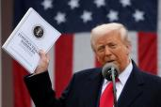](https://nypost.com/2025/04/05/opinion/why-trumps-tariffs-may-not-deliver-an-american-golden-age/)

To be clear: Even protests that *do* qualify as free speech have an obviously hateful agenda — why else single out Israel?

In Syria, militias tied to the new government just slaughtered over 1,000 civilians, to no outcry on any US campus, just as previous Syrian governments’ massacres over the last decade raised not a peep of protest.

For whatever reason, most of the global left has opted to embrace and/or exploit antisemitism — and the confused progressive leadership of US higher education has dithered (or worse) in the face of this unholy alliance.

Now the Trump administration has begun to hold academia to account for its failings, as well as acting directly against those like Mahmoud Khalil who abuse America’s welcome to foster violent hate.

This is both a defense of decency and a push against the perversion of privilege, and we look forward to seeing a lot more of it.