**[ANTISEMITISM EXPOSED](https://www.foxnews.com/category/topic/anti-semitism)**

**Ivy League anti-Israel ringleader Mahmoud Khalil fights deportation in New Jersey court**

A hearing on Khalil's case was held in New Jersey on Friday

[**Sarah Rumpf-Whitten**](https://www.foxnews.com/person/r/sarah-rumpf) [**Fox News**](https://www.foxnews.com/)

Published March 28, 2025 6:00am EDT

Attorneys for former Columbia University graduate student Mahmoud Khalil appeared in a New Jersey courtroom on Friday to take on the [Trump administration](https://www.foxnews.com/category/person/donald-trump) as the president's team fights to deport the anti-Israel activist.

A 10 a.m. hearing was held in federal court in [Newark, New Jersey,](https://www.foxnews.com/category/us/us-regions/northeast/new-jersey) before Judge Michael E. Farbiarz. New York Judge Jesse Furman transferred the case to New Jersey, where Khalil was in custody when his attorneys filed their original writ of habeas corpus challenging his detention.

Khalil has since been relocated to Louisiana, where the Trump administration wants the case to proceed. During the hearing, Khalil's attorney argued that because the initial habeas petition was filed while Khalil was held in New Jersey, the state of New Jersey retains jurisdiction.

Dozens of protesters swarmed the courthouse Friday morning, waving flags, holding signs and chanting outside the building. Some were chanting "up up with liberation, down down with deportation."

[**IVY LEAGUE ANTI-ISRAEL RINGLEADER MAHMOUD KHALIL WITHHELD DETAILS OF FOREIGN TIES FROM VISA APPLICATION: FEDS**](https://www.foxnews.com/us/ivy-league-anti-israel-ringleader-mahmoud-khalil-withheld-details-foreign-ties-from-visa-application-feds)

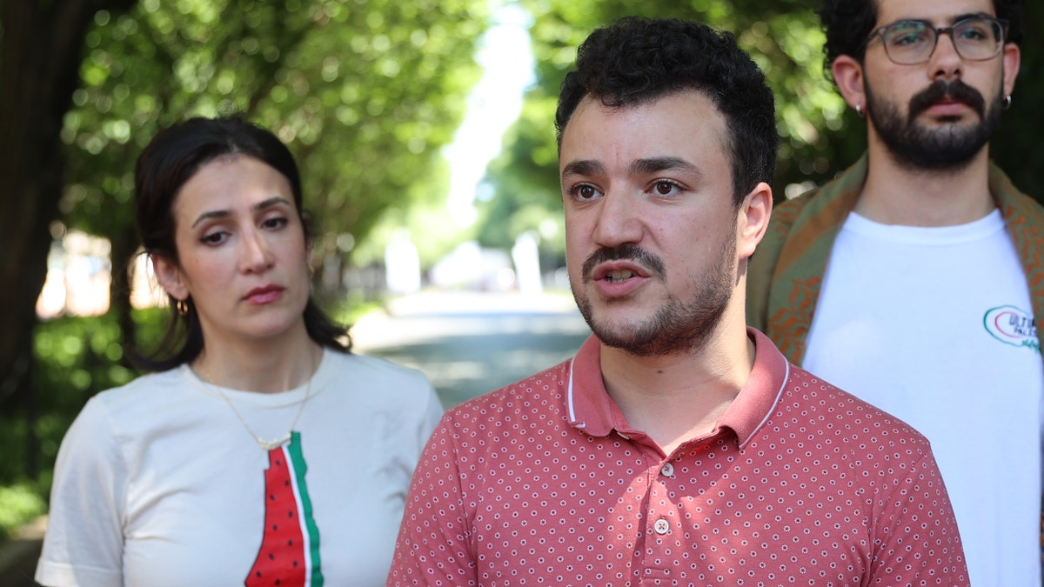

**Columbia University student Mahmoud Khalil talks to the press during a press briefing organized by pro-Palestinian protesters who set up a new encampment at Columbia University's Morningside Heights campus on Friday evening in New York City on June 1, 2024. (Getty Images)**

The hearing lasted for an hour, with no decision from Judge Furman. He said that he would not rule from the bench, but would rule "as quickly as I can in a thoughtful way." He also said he would not touch any other pending motions in this case until jurisdiction – in Louisiana or in New Jersey – has been decided.

Khalil's lawyers spoke outside following the Friday morning hearing, encouraging protesters to continue to stand in solidarity with the anti-Israel ringleader.

"There are people behind you who are here for him, who are still standing in solidarity with the Palestinian people in defense of their human rights, and in solidarity with the many others at this point, who, like Mr. Khalil, are either in ICE custody because of their constitutionally protected speech or are at risk of ICE detention and deportation because of their speech and their viewpoints, which the government happens to disagree with," Ramzi Kassem, a professor of law and founding director of CLEAR at the City University of New York, said.

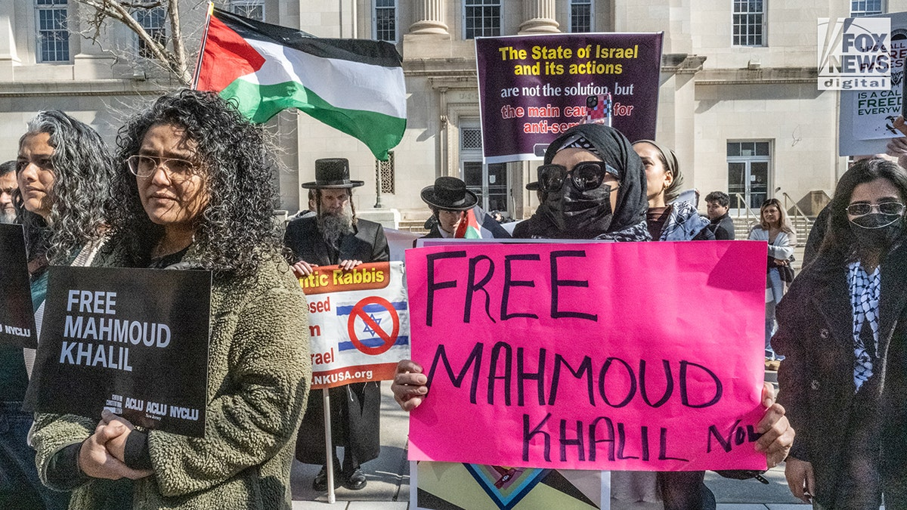

**People gather for a protest in support of Mahmoud Khalil in front of a federal courthouse in Newark, New Jersey on March 28, 2025. Khalil's lawyers are responding to a motion by the government to have Khalil's case moved to Louisiana. (Stephanie Keith for Fox News Digital)**

Kassem encouraged Khalil's supporters to continue their crusade to free the Columbia University graduate.

"What's most important is for all of us to keep up the pressure to let this government know that it cannot suppress speech, any form of speech, including pro-Palestinian speech," he said.

"The part that we can control is keeping the pressure up, because, of course, the government is banking on these people behind you who are protesting, who are rallying for Mahmoud and the others to dissipate," he continued.

* People gather for a protest in support of Mahmoud Khalil in front of a federal courthouse in Newark, New Jersey on March 28, 2025. Khalil's lawyers are responding to a motion by the government to have Khalil's case moved to Louisiana. (Stephanie Keith for Fox News Digital)

Khalil, who holds legal permanent resident status in the U.S., came under the administration's wrath for his alleged support of Hamas terrorists in the aftermath of the Oct. 7, 2022 attack on Israel. The Department of Homeland Security (DHS) said Khalil "led activities aligned to Hamas, a designated terrorist organization."

"We will be revoking the visas and/or green cards of Hamas supporters in America so they can be deported," [Secretary of State Marco Rubio](https://www.foxnews.com/world/rubio-warns-visas-revoked-all-foreign-student-activists-amid-tufts-arrest) wrote in a post on X earlier this month.

The DHS alleged in a [Sunday filing](https://www.documentcloud.org/documents/25866289-119122326097/) in the U.S. District Court of New Jersey that Khalil willfully failed to disclose his employment with the Syrian office in the British Embassy in Beirut when he applied for permanent U.S. residency.

Federal officials alleged that Khalil was "inadmissible at the time of his adjustment" because of "fraud or willful misrepresentation of material fact" in his status application.

The agency also accused Khalil of failing to disclose his work with the United Nations Relief and Works Agency for Palestine Refugees and membership in [Columbia University Apartheid Divest](https://www.foxnews.com/us/israeli-hostages-families-sue-mahmoud-khalil-columbia-organizers-alleged-hamas-propaganda-arm-nyc).

"It is black-letter law that misrepresentations in this context are not protected speech," the filing said. "Thus, Khalil’s First Amendment allegations are a red herring."

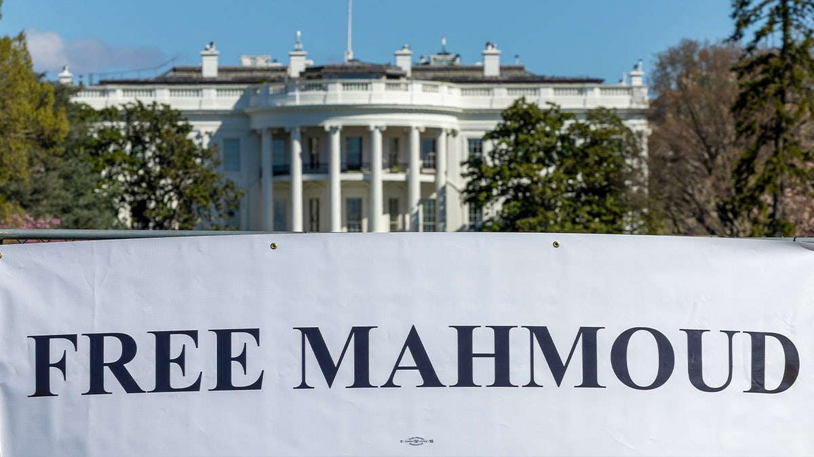

**"Win Without War Banner" outside the White House on March 26, 2025 in Washington, D.C. The group is calling on President Trump to free Mahmoud Khalil, a Palestinian refugee﻿ whose green card was revoked over his involvement in demonstrations at Columbia University. (Tasos Katopodis/Getty Images for Win Without War)**

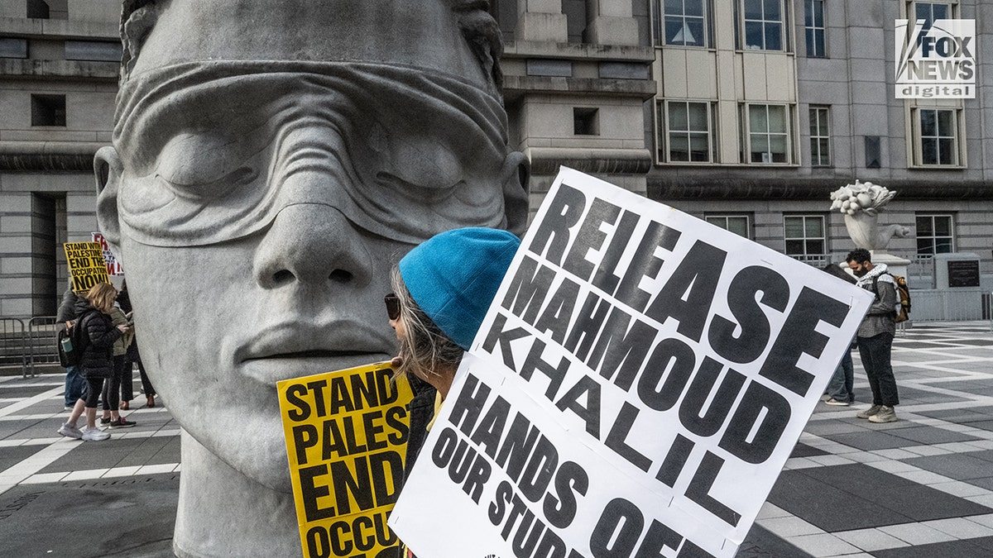

**People gather for a protest in support of Mahmoud Khalil in front of a federal courthouse in Newark, New Jersey on March 28, 2025. Khalil's lawyers are responding to a motion by the government to have Khalil's case moved to Louisiana. (Stephanie Keith for Fox News Digital)**

Marc Van Der Hout, one of Khalil’s lawyers, and Khalil’s wife, Noor Abdalla, released statements in a series of Instagram posts. They characterized Khalil as a "political prisoner detained at an [ICE facility in Louisiana."](https://www.foxnews.com/category/us/us-regions/southeast/louisiana)

Khalil's lawyers have argued that his support for Palestinians is protected by free speech and that the administration's deportation efforts are an effort to prevent his "current and future speech" and to deter others from doing the same.

"The Policy, including as-applied to Mr. Khalil, does not give the proper notice to anyone residing in the country which of their otherwise-lawful speech, opinions, beliefs, or advocacy will result in the government targeting them for detention and removal, and it provides government officials with unfettered discretion to target disfavored speech," the lawyers wrote.

His lawyers also noted that the administration does not define who qualifies as a "Hamas supporter." They say that there is no clarity on Khalil's activities that are "aligned to Hamas."

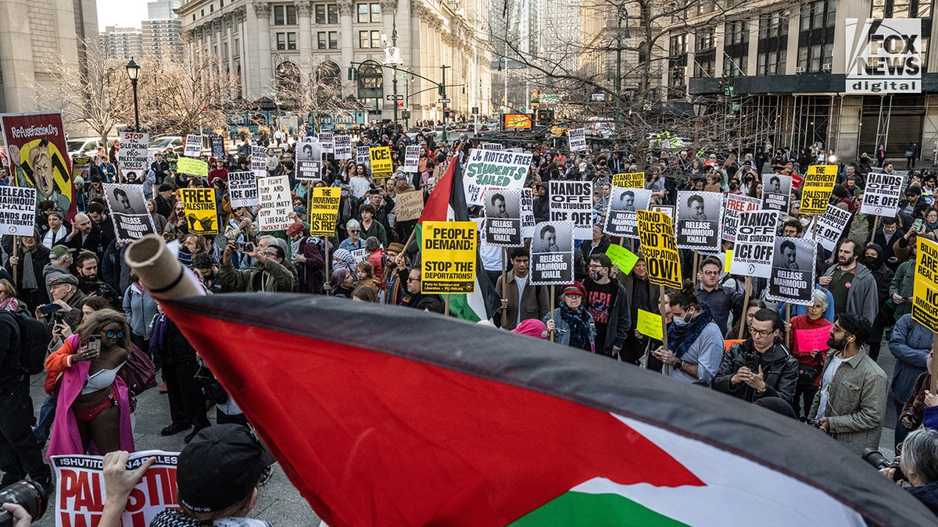

**Protesters rally against the arrest of former Columbia graduate student Mahmoud Khalil in New York City on Monday, March 10, 2025. Khalil was one of the main student organizers of the student encampment last year at Columbia University. (Stephanie Keith for Fox News Digital)**

A federal judge in the [Southern District of New York](https://www.foxnews.com/politics/trump-admin-urged-probe-allegations-pro-hamas-college-groups-had-prior-knowledge-oct-7-attack) blocked the Trump administration’s efforts to deport Khalil on March 10.

[**VIDEO SHOWS ARREST OF COLUMBIA ANTI-ISRAEL RINGLEADER MAHMOUD KHALIL**](https://www.foxnews.com/us/video-shows-arrest-columbia-anti-israel-ringleader-mahmoud-khalil)

On March 18, Khalil wrote: "In the weeks ahead, students, advocates, and elected officials must unite to defend the right to protest for Palestine. At stake are not just our voices, but the fundamental civil liberties of all. Knowing fully that this moment transcends my individual circumstances, I hope nonetheless to be free to witness the birth of my first-born child."

Khalil, [a native of Syria](https://www.foxnews.com/category/world/conflicts/syria) and citizen of Algeria, entered the U.S. on a student visa in 2022 and later filed to become a permanent resident in 2024.

He is the first target in the Trump administration's crusade to revoke student visas for participating in protests.

**WATCH MAHMOUD KHALIL'S ARREST:**

[[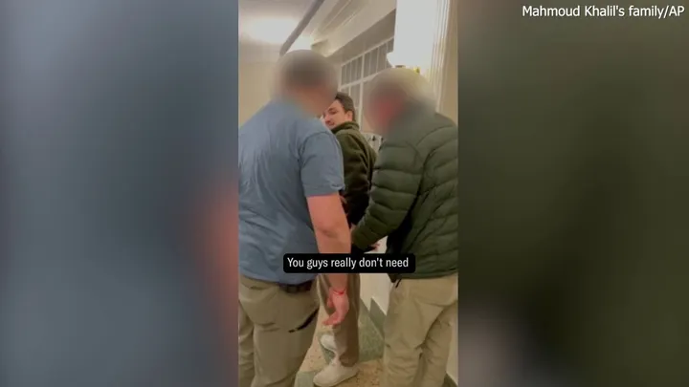](https://www.foxnews.com/video/6370275016112)Video](https://www.foxnews.com/video/6370275016112)

Khalil’s arrest comes after President Donald Trump issued a Jan. 29 [executive order](https://www.whitehouse.gov/presidential-actions/2025/01/additional-measures-to-combat-anti-semitism/) titled "Additional Measures to Combat Anti-Semitism" which mandates colleges "report activities by alien students and staff" on the grounds of antisemitism.

[**COLUMBIA STUDENT CLAIMS CLASSMATE ARRESTED BY ICE ‘HATES AMERICA’**](https://www.foxnews.com/politics/safer-without-him-columbia-student-claims-classmate-arrested-ice-hates-america)

The anti-Israel protests wreaked havoc on college campuses following the Oct. 7, 2023 attacks, leading to Trump's campaign promise to [revoke foreigners' student visas](https://www.foxnews.com/politics/state-department-revokes-first-visa-foreign-student-linked-hamas-supporting-disruptions).

"To all the resident aliens who joined in the pro-jihadist protests, we put you on notice: come 2025, we will find you, and we will deport you," Trump is quoted in a fact sheet issued by the White House. "I will also quickly cancel the student visas of all Hamas sympathizers on college campuses, which have been infested with radicalism like never before."

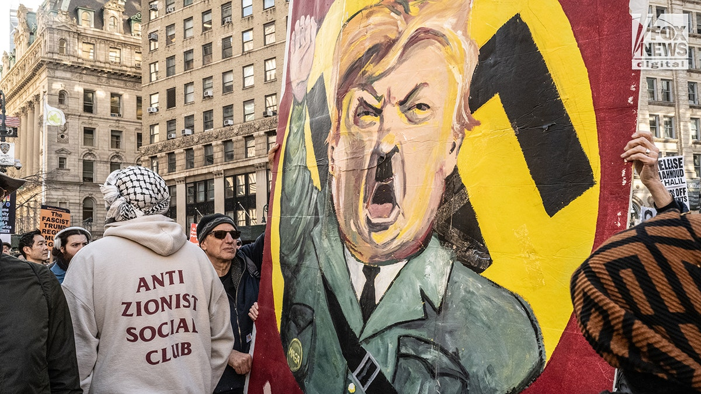

**Protesters rally against the arrest of former Columbia graduate student Mahmoud Khalil in New York City on Monday, March 10, 2025. Khalil was one of the main student organizers of the student encampment last year at Columbia University. (Stephanie Keith for Fox News Digital)**

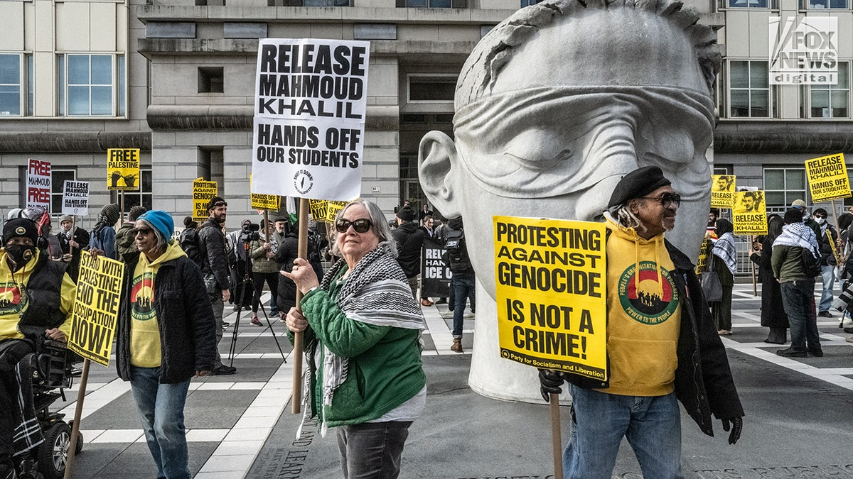

**People gather for a protest in support of Mahmoud Khalil in front of a federal courthouse in Newark, New Jersey on March 28, 2025. Khalil's lawyers are responding to a motion by the government to have Khalil's case moved to Louisiana. (Stephanie Keith for Fox News Digital)**

DHS and ICE did not respond to Fox News Digital's request for comment.

Khalil is represented by Amy Greer from Dratel & Lewis, the Center for Constitutional Rights, the New York Civil Liberties Union, the American Civil Liberties Union, and Alina Das, co-director of the Immigrant Rights Clinic at New York University School of Law. Fox News Digital has reached out for comment.