**MAGA law group files briefs in support of Trump executive order ending birthright citizenship**

**'My expectation is that this is a no-brainer. The law is clear, "subject to the jurisdiction thereof" has to mean something,' said America First Legal Vice President Dan Epstein**

By [Peter Pinedo](https://www.foxnews.com/person/p/peter-pinedo)

Published February 7, 2025 8:00am EST

[[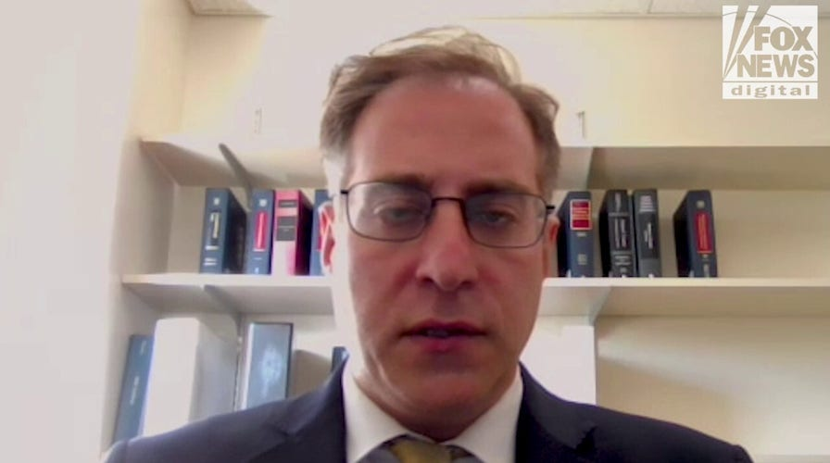](https://www.foxnews.com/video/6368375200112) Video](https://www.foxnews.com/video/6368375200112)

[**America First Legal files amicus briefs in support of Trump executive order ending birthright citizenship**](https://www.foxnews.com/video/6368375200112)

America First Legal VP Dan Epstein discusses his group's amicus briefs in support of President Donald Trump's executive order ending birthright citizenship for the children of illegal immigrants, which Epstein said is ‘fully constitutional’ and necessary.

America First Legal filed two amicus briefs this week in support of [President Donald Trump’s executive order ending birthright citizenship](https://www.foxnews.com/politics/trump-end-birthright-citizenship-children-illegal-immigrants-via-executive-order) for the children of illegal immigrants.

The firm filed the briefs on behalf of [House Judiciary Committee Chairman Jim Jordan](https://www.foxnews.com/category/person/jim-jordan), R-Ohio, and 17 other committee members.

Despite there being [nearly two dozen Democrat-run states](https://www.foxnews.com/politics/nearly-2-dozen-states-sue-trump-admin-over-birthright-citizenship-order-unprecedented) and civil rights groups suing to stop the order and [two federal judges ruling to temporarily block it](https://www.foxnews.com/politics/second-federal-judge-blocks-trump-birthright-citizenship-order), America First is arguing that there is a clear constitutional basis for denying citizenship to illegal migrants who have broken the country’s immigration laws.

[**'BLATANTLY UNCONSTITUTIONAL': US JUDGE TEMPORARILY BLOCKS TRUMP'S BAN ON BIRTHRIGHT CITIZENSHIP**](https://www.foxnews.com/politics/blatantly-unconstitutional-u-s-judge-temporarily-blocks-trumps-ban-birthright-citizenship)

President Donald Trump signs executive orders in the Oval Office of the White House in Washington, D.C., on Jan. 20. (Anna Moneymaker/Getty Images)

Trump’s order titled "Protecting the Meaning and Value of American Citizenship" states that "the privilege of United States citizenship does not automatically extend to persons born in the United States" when that person’s parents are either unlawfully present in the U.S. or when the parents’ presence is lawful but temporary.

The briefs — which were filed in the federal courts for theWestern District of Washington and the District of Massachusetts*—*argue that based on the "text and history" of the 14th Amendment, the Constitution does not confer citizenship on the children of unlawfully present aliens. The briefs claim that citizenship in the U.S. is a political right, not an automatic entitlement.

The 14th Amendment was passed in 1868 and was designed to extend citizenship to African-American former slaves. The amendment states that "all persons born or naturalized in the United States, and subject to the jurisdiction thereof, are citizens of the United States and of the State wherein they reside."

[Dan Epstein](https://www.foxnews.com/person/e/dan-epstein), vice president of America First Legal, told Fox News Digital that the phrase "subject to the jurisdiction thereof" means that citizens must owe their political allegiance to the U.S., not some foreign power or culture. He said that Trump’s order would restore the constitutional principle that only those who are subject to the jurisdiction of the U.S. — that is loyal, law-abiding Americans — are citizens.

[**NUMEROUS US STATES SUE TRUMP OVER BIRTHRIGHT CITIZENSHIP EXECUTIVE ORDER AS SUPREME COURT COULD MAKE FINAL DECISION**](https://www.foxnews.com/video/6367592775112)

President Donald Trump’s executive order is an effort to end birthright citizenship for the children of illegal immigrants. (AP Photo/Evan Vucci | Christian Torres/Anadolu via Getty Images)

"This executive order is constitutional and legally valid," said Epstein. "The Constitution makes clear that it is not the ‘natural born citizen clause.’ It is a ‘natural born and subject to the jurisdiction thereof clause.' And we can't just scratch out ‘subject to the jurisdiction thereof.’ ‘Jurisdiction thereof’ means something; it means you are a loyal subject to American jurisdiction and if you're a disloyal subject — which is clearly someone whose parents entered here illegally — it means you don't believe in the law."

**"**Congress has not specifically authorized that any individual born to illegal aliens on U.S. soil is by definition a citizen. That's nowhere in the statute," he explained. **"**If Congress decided to pass a law and the courts said it was constitutional, and it said that, in fact, if you're born on American soil, you're a citizen, well, then, we're bound by that law and the Supreme Courts and the federal courts affirming that. But that's just not the law."

Epstein said that the U.S. policy of extending citizenship to anyone born on U.S. soil, including those born to illegal immigrants, breaks with American tradition and disrupts the rule of law.

[**REPUBLICAN STATE AGS BACK TRUMP BIRTHRIGHT CITIZENSHIP ORDER IN COURT FILING: 'TAXPAYERS ARE ON THE HOOK'**](https://www.foxnews.com/politics/republican-state-ags-back-trump-birthright-citizenship-order-court-filing-taxpayers-hook)

Dan Epstein, vice president of America First Legal, said that the U.S. policy of extending citizenship to anyone born on U.S. soil, including those born to illegal immigrants, breaks with American tradition and disrupts the rule of law. (U.S. Border Patrol)

"There’s a lot that hangs in the balance here," he explained. **"**If we have an interpretation of the 14th Amendment that says that anyone born here is like African-Americans who have a history of slavery or of terrible things, then we actually dilute that American tradition of enfranchising the rights of the descendants of former slaves and that is not what the 14th Amendment was designed to do."

Despite Trump’s executive order being currently blocked, Epstein said that he is optimistic that the [Supreme Court](https://www.foxnews.com/category/politics/judiciary/supreme-court) will eventually rule in Trump’s favor.

"My expectation is that this is a no-brainer. The law is clear, ‘subject to the jurisdiction thereof’ has to mean something," he said. "And whether you're looking at the legislative history of that phrase or you're looking at how it's been applied — even in [[U.S. vs.] Wong Kim Ark](https://www.foxnews.com/us/this-day-in-history-march-28), the kind of preeminent case on this — makes clear that jurisdiction means allegiance. So, it's not a very hard question. It's a very clear question. And the law has a very clear answer."

Peter Pinedo is a politics writer for Fox News Digital.